|  |  |  |  |
| --- | --- | --- | --- |
| **TITLE:** | Fast Pack Order Processing - SONY PLAY STATIONS | | |
| **sop #:** | OCP-16 | **revision #:** | 1 |
| **EFFECTIVE DATE:** | May 23, 2020 | | |
| **OWNER:** | Ron McDowell | | |

## REVIEWERS

|  |  |  |  |
| --- | --- | --- | --- |
| Name | tITLE | sIGNATURE | dATE |
| Susan Kiernan | Fulfillment Supervisor | Signed | May 23, 2020 |
| Gord Callaghan | Distribution Supervisor | Signed | May 23, 2020 |

## APPROVER

|  |  |  |  |
| --- | --- | --- | --- |
| Name | tITLE | sIGNATURE | dATE |
| Ron McDowell | Distribution Manager | Signed | May 23, 2020 |

# 1.0 purpose

To establish and maintain an effective inbound shipment activity at Radiant Courtneypark facility. To provide guidance to dock personnel with an effective procedure in managing warehousing operations.

The purpose of this document is to be used as a training tool for all Radiant employees that are responsible and perform the task as assigned.

# 2.0 SCOPE

The following document covers the pre-receiving and inbound activities that take place in Radiant Logistics at 1280 Courtneypark Dr. E. This document covers the physical receipt of goods into warehouse.

# 3.0 equipment

Designates must wear appropriate PPE, such as safety shoes, harness, reflective vest, safety goggles etcetera, as instructed.

# 4.0 definitions

| **Definition** | **Explanation** |
| --- | --- |
| **Bin** | A systematic and physical location where the product resides in the warehouse |
| **Electronic Data Interchange (EDI)** | EDI is the computer to computer or system to system transfer of business documents in a standard electronic format between Radiant and its customers |
| **Shipment Date / Lot & Expiry** | Products with Lot number and Expiry Date closest to current date are usually shipped first, and processed by province, unless otherwise requested by customers. |
| **Shipping Agent Code** | Also, referred to as Carrier. |
| **Ship-to State Code** | Carriers typically take a set number of days to deliver to different Canadian provinces, known as Ship-to State Code in Navision.  There are four day, three day, two day, and one day shipping points. Orders with longest delivery lead times are processed first.  Please refer to map showing average transit times in Annex ‘Transit Times’ |
| **Sell-to Customer No** | Customer categories, in order of descending priority:   1. Special Customer - Any customer that requires special packaging only if certain Carriers are assigned to ship order. 2. Special Customer - Any customer that requires special packaging regardless of the Carrier. Example: Amazon. 3. Regular customers - Any customer without special packaging requirements for any product type. |

# 5.0 Responsibility

|  |  |
| --- | --- |
| **Responsibility** | **Activity** |
| **Warehouse Planner** | * Any member of Inventory Control team responsible for investigating inventory issues/requirements * Ensure that controls in inventory are properly implemented |
| **Order Packer** | * Also, known in this process as “Auditor” |
| **Fulfillment Manager / Supervisor** | * Ensure that warehouse personnel are complying with order fulfillment rules and procedures * Ensure that physical and system information are aligned and accurate |
| **Distribution Manager** | * Also, known in this process as “Warehouse Manager” * Ensure that all warehouse personnel executing this process have been adequately trained and that the process is being followed. * That this procedure is regularly revisited and updated due to, but not limited to, the following reasons: risk identified, health and safety considerations, and stakeholders needs. |

# 6.0 policy

## 6.1 IMPORTANT INFORMATIONS BEFORE PROCEEDING TO PROCESSING ORDERS

|  |  |  |  |
| --- | --- | --- | --- |
| **MUST CONSIDER WHEN PROCESSING AN ORDER** | | | |
| **CUSTOMER** | **Cubage and Height Restrictions** | **SKID TYPE** |
| Harmony / Loblaws | 40 x 48 x **66** | CHEPS |
| Best Buy / Source | 40 x 48 x **54** | Regular |
| SCM - Mississauga | 40 x 48 x **72** | CHEPS |
| SCM - Cornwall / Calgary | 40 x 48 x **74** | CHEPS |
| Shoppers / Matrix | 40 x 48 x **68** | CHEPS |
| London Drugs | 40 x 48 x **64** | Regular |
| Amazon | 40 x 48 x **72** | Regular |
| Canadian Tire - Brampton | 40 x 48 x **57** | CHEPS |
| Canadian Tire - Mississauga | 40 x 48 x **78** | CHEPS |

## 6.2 AMAZON ORDERS TO BE AHEAD IN ALL ORDER PROCESSING:

1. Consider the following additional steps when processing orders for Amazon:
2. The auditor will post the Amazon orders as soon as possible after completing steps 1 to 37.

**NOTE:** This becomes priority #1 for Order Fulfillment group over other orders.

1. The Traffic team will ensure the Amazon appointment log is immediately updated with the appointment information after receiving such info back from Amazon.

**NOTE:** This becomes priority #1 for Traffic team over other orders.

1. The Traffic team will ensure Navision is immediately updated with the appointment information after receiving confirmation back from Amazon

**NOTE:** This becomes priority #1 over other orders.

1. The Traffic team will forward the appointment email received from Amazon immediately to the warehouse.

**NOTE:** This becomes priority #1 for the Warehouse Department over other orders.

1. Ensure that shipments for Amazon is loaded and shipped as per assigned schedule

## 6.3 CREATING A DELIVERY APPOINTMENT REQUEST

1. Customer service will send email to fulfillment. wli with instructions ie rush, label and shipping information.

**Note**: in case of rush orders, office operations to alert supervisor with specific details. Rushes should be printed on green paper, and placed in the same area as other orders). Sony play stations is not included. Warehouse to emphasize rush orders on the paperwork.

1. order control supervisor/designate to hand over physical paperwork to designated picker(s) for physical picking.
2. Designated picker to:
3. Coordinate with auditor and determine optimal way to pick product
4. If products required lot number and expiry dates to follow, picker(s) should ensure that this is followed during picking activity
5. Pick product from designated locations
6. Bring picked product to the dc staging area.
7. Place paperwork with staged product.
8. Advise dc auditor that picking is complete.

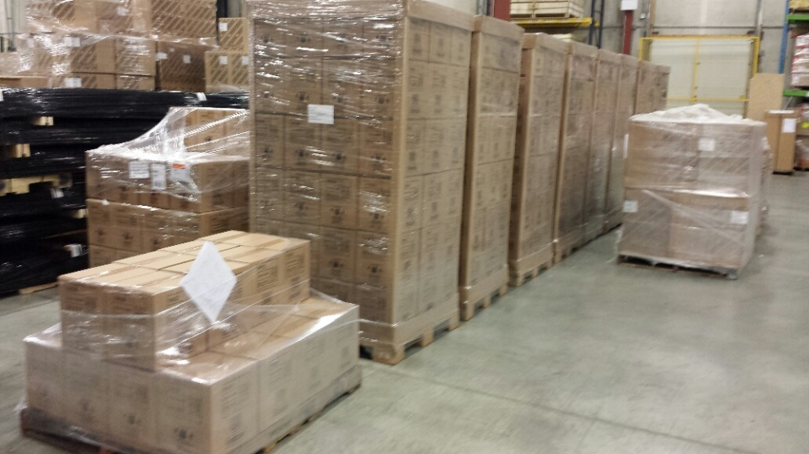

1. Auditor to:
2. Blind count staged product and note blind count.
3. Confirm count with the paperwork
4. Also, verify count in NAV

# 7.0 references

# 8.0 revision history

|  |  |  |
| --- | --- | --- |
| **Revision #** | **Revision Date** | **Description** |
| 1 | May 21, 2020 |  |